


Budget Holders Manual
Version 1.2
October 2015/16
Document History:

Version | Date | Author | Amendment History
1.0 | 20/10/15 | Head of Finance | First draft for review
1.1 | 05/11/15 | Head of Finance | Feedback from SFT incorporated
1.2 | 16/11/15 | Head of Finance | Feedback form Internal Audit

Contributors:

Name | Role & Responsibility | Date | Version
Darren Baker * | Finance Officer | 20/10/15 | 1.0
Naomi Chun * | Assistant Accountant | 20/10/15 | 1.0
Ivan Court * | Senior Accountant | 20/10/15 | 1.0
Chris Edworthy | Senior Accountant | 20/10/15 | 1.0
Angela Hibbard * | Head of Finance | 20/10/15 | 1.0
Suzanne Pollard * | Senior Finance Manager - Corporate | 20/10/15 | 1.0
Mike Rodgers * | Management Accountant | 20/10/15 | 1.0

* Denotes Budget Holder working Group Member

Reviewers:

Name | Role & Responsibility | Date | Version
Ben Chilcott | Locality CFO | 30/10/15 | 1.0
Kevin Wheller | Locality CFO | 30/10/15 | 1.0
Davina Ross | Head of Finance - Partnerships | 30/10/15 | 1.0
Sam Gingell | Internal Audit | 09/11/15 | 1.1

Approvals:

Name | Role & Responsibility | Date | Version
Hugh Groves | Executive Lead

Table of Contents

1. Introduction 4
2. Brief overview of the NHS structure 4
2.1 Commissioning Structure 4
2.2 How the money flows 6
3. CCGs Financial Responsibility 7
4. Budgetary Control 8
5. Budget Holder Responsibilities 9
5.1 Definition of a budget holder 9
5.2 Budget holders Responsibility 10
6. Finance Team responsibilities 10
6.1 Financial Accounts 11
6.2 Management Accounts 11
7. Budget Holder and Management Accountant Monthly Meetings 12
8. Understanding Your Budget Statement 13
9. Understanding Your Spend 15
9.1 Oracle 15
9.2 Coding 16
9.3 Budget holder database 17
9.4 Invoices 17
9.4.1 Approving an Invoice 17
9.4.2 Rejecting an Invoice 18
9.4.3 Payment Runs 19
9.5 Recharges 19
9.6 Finance Journals 20
9.6.1 Accruals 20
9.6.2 Prepayments 20
9.6.3 Correction Journals 20
9.6.4 Forecast Journals 21
10. Understanding your variance from Budget 21
10.1 Reasons for over/under performance 21
10.2 Corrective action 23
11. Budget Setting Process 24
11.1 Annual Planning 24
11.2 Budget Sign off 25
11.3 Budget Virements 25
12. VAT in the NHS – an introduction 26

Introduction

A key component of any organisation’s finance management and control is the setting and management of budgets. The purpose of this document is to set out the rules and processes of budget management to be adhered to with Northern, Eastern and Western Devon CCG (NEW Devon CCG). The document provides context as to the CCGs role in the financial environment of the wider NHS and statutory duties as well as the roles and responsibilities of both Budget Holders and the Finance function within the CCG.

The document has been prepared by the Finance department based on the current processes within the CCG. Further iterations will be issued as processes are improved and refined. Its intention is to be used as a ‘how to’ guide to support budget managers in their day to day tasks and understanding of the budgeting framework.

This manual will be supported by regular modules of budget holder training and ongoing support and guidance from the finance team.

Not all sections of this manual will be relevant to all budget holders and therefore each section will start with a ‘relevant to table’ for ease as below

Relevant To |  | Content
PBM | ✓ | Background Information | ✓
RCBM | ✓ | Understanding of area | ✓
All | ✓ | Quick Reference Guide | ✓

Key
PBM = Programme Budget Managers
RCBM = Running Cost Budget Managers

Brief overview of the NHS structure

Relevant To |  | Content
PBM |  | Background Information | ✓
RCBM |  | Understanding of area
All | ✓ | Quick Reference Guide

2.1 Commissioning Structure

The NHS underwent a comprehensive restructure following the Health and Social Care Act in 2012 which was implemented on 1st April 2013. This led to a change in how services were commissioned with a number of new organisations being formed to replace the previous Primary Care Trusts. This resulted in the formation of Clinical Commissioning Groups (CCGs) being clinically led organisations responsible for the health needs of their local population and therefore responsible for the commissioning of secondary care, mental health and community and rehabilitation services. Alongside this NHS England was formed with a duel role of providing national leadership of the NHS and overseeing the operation of CCGs and direct commissioning of Primary Care services, Specialised Services, Offender health and Armed Forces healthcare.
Other services commissioned are via Public Health England (PHE) who provides national leadership and expert services to support public health, and also works with local government and the NHS to respond to emergencies.

Other organisations created as part of the NHS restructure where Commissioning Support Units (CSU) who provide services to CCGs to enable them to fulfil their commissioning roles. This may be transactional services in the form of finance, contracting or information services or transformational services such as service redesign. CSUs are currently hosted by NHS England.

Regulation of the provider sector transferred from previous Strategic Health Authorities to the Trust Development Agencies for NHS Trusts and Monitor for NHS Foundation Trusts with clinical regulation of all healthcare provision being provided by the Care Quality Commission.

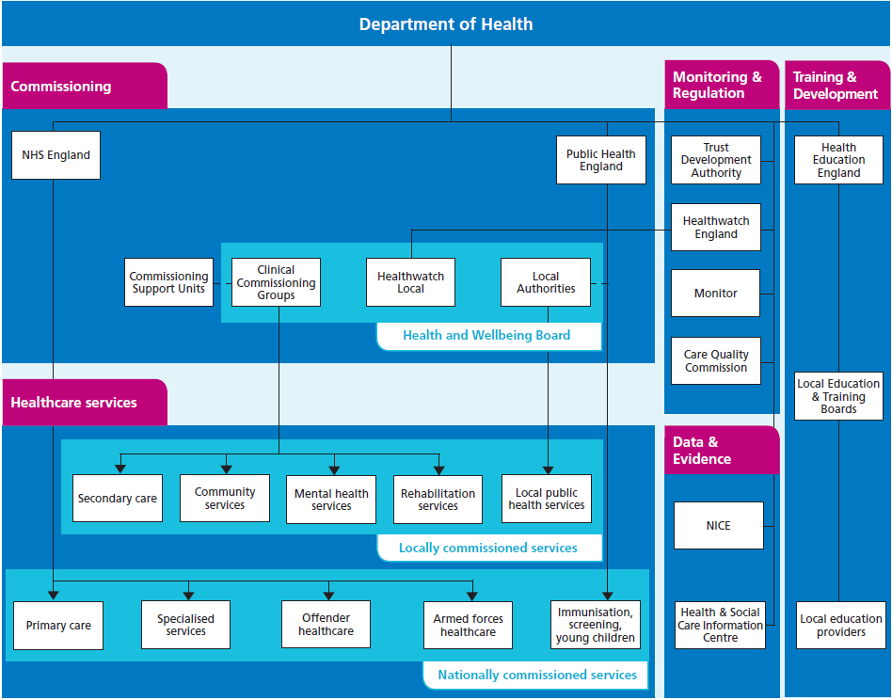

Source; understanding the NHS
http://www.nhs.uk/NHSEngland/thenhs/about/Documents/simple-nhs-guide.pdf

2.2 How the money flows

The flow of funding through the NHS is via the Treasury who allocates funding to the Department of Health (DoH) who in term allocates this to NHS England (less an element withheld for running costs at the DoH). This funding is then allocated out to commissioning organisations (CCGs and NHS England direct commissioning arm) based on a national funding formula. The commissioning organisations then use this funding to commission services from NHS healthcare providers and private sector organisations to meet the needs of the population.

The financial position of all commissioning organisations that are overseen by NHS England (Directly commissioned services and CCGs) are consolidated into an overall national financial position to report the financial performance of commissioning services within the NHS in England (excludes Scotland, Wales and Northern Ireland).

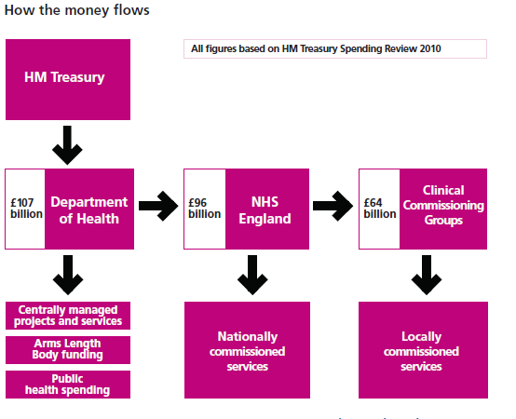
Source; understanding the NHS
http://www.nhs.uk/NHSEngland/thenhs/about/Documents/simple-nhs-guide.pdf

CCGs Financial Responsibility

Relevant To |  | Content
PBM |  | Background Information | ✓
RCBM |  | Understanding of area
All | ✓ | Quick Reference Guide

CCGs in England have a number of statutory financial duties as laid out in the Health and Social Care Act of 2012. The main duties relevant to this document are:

Area | Description | Meaning
Financial duties of  CCGs: expenditure | Each CCG has a duty to perform its functions for each financial year so as to ensure that its expenditure does not exceed the total amount allocated under the NHS England allocation formula or any additional sums received in year. | The CCG must not overspend in year i.e. the CCG has a legal duty to breakeven
Financial duties of  CCGs: use of  resources | Any capital or revenue  resource use by a CCG must not exceed the amounts set out by NHS England. | The CCG must not over spend against revenue resources or capital resources independently of each other. Underspends on capital resources cannot be offset by overspend on revenue resources
Value for Money | CCGs are charged with economy, efficiency and effectiveness in their use of resources (see definitions below) | CCG are spending public money and therefore must be accountable for the use of that money

Economy – minimising costs of inputs
Efficiency – Maximising he ratio of outputs to inputs
Effectiveness – achievement of intended outcomes

In addition to the legal statutory duties there are a number of additional financial planning requirements known as business rules that CCG are expected to deliver. The main business rules relevant to this document are set out below:

Area | Description | Meaning
Running Cost allocation | CCGs running cost expenditure must not exceed the running cost allowance given to the CCG based on the NHS England per head of population allocation formula | The CCG must not over spend against its running cost budget
Delivery of Surplus | There is an expectation that CCGs will plan to deliver a 1% surplus against allocated resources | Whilst the statutory duty is to breakeven there is an expectation from NHS England that CCGs will actually under spend by 1% of their budget. For NEW Devon CCG this would be circa £10m
Contingency resources | There is a planning requirement for CCGs to hold a contingency reserve of no less than 0.5% of their allocation and a non-recurrent headroom reserve of 1% of their allocation | To support sound financial planning there is an expectation by NHS England that CCGs plan to hold a reserve at the start of the year of 0.5% to fund unforeseen costs in year. In addition CCGs are expected to hold a reserve of 1% to fund non recurrent spend/ transformational change in year. For NEW Devon CCG this would be circ. £5m and £10m respectively

Budgetary Control

Relevant To |  | Content
PBM |  | Background Information
RCBM |  | Understanding of area | ✓
All | ✓ | Quick Reference Guide

The budget is the representation of the CCGs financial plan for the year. The budget demonstrates where the plan has allocated resources to different areas within the organisation. Budgetary control is the means by which that plan is controlled to ensure delivery in year. The aim of budgetary control is to provide a formal basis for monitoring the progress of the organisation as a whole and of its component parts. It is the expectation that spend against each area of the budget will be within budgeted levels.

The hierarchy of budgetary control is as follows:

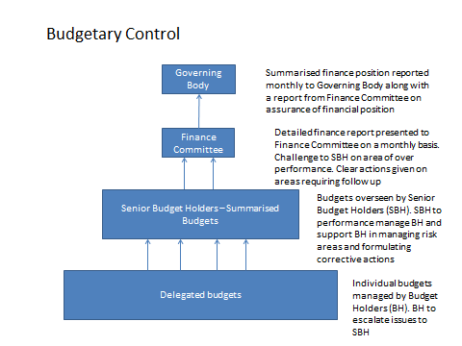

Delegated budgets are consolidated for reporting purposes into CCG locality positions, Planning Delivery Unit (PDU) or the Nursing and Quality Directorate and corporately into a CCG wide financial position.

Budget Holder Responsibilities

Relevant To |  | Content
PBM |  | Background Information
RCBM |  | Understanding of area | ✓
All | ✓ | Quick Reference Guide

5.1 Definition of a budget holder

There are two types of budget holders recognised in the CCG:

Senior Budget Holder (SBH) - The SBH is defined as the senior responsible executive who has the accountability for delivery of their assigned budget. In other words they hold the corporate accountability for the delivery of the budget. By holding the accountability they must answer to the Governing Body (or sub-committees of) for any poor performance of that budget spend against plan.

Budget Holders (BH) are those persons within a Senior Budget Holder’s sphere of management who have been delegated the managerial responsibility for managing that budget. A budget holder will have delegated authority on behalf of the senior budget holder to make decisions independently in relation to the budget. A budget holder may delegate day to day operational issues within the team but the budget holder remains responsible to the Senior Budget Holder for delivery of the budget.

5.2 Budget holders Responsibility

Budget holders who have the authority to spend and generate income on behalf of the CCG are duty bound to support the organisation in achieving the financial duties detailed in section 3. This can be achieved through adherence to the following key budget holder responsibilities

- Adhering to the CCGs Scheme of Delegation and Standing Financial instructions
- Managing the budget both efficiently and economically, ensuring value for money at all times
- Checking invoices to ensure the CCG have been charged appropriately for goods and services received and to ensure that the coding has been correctly applied
- Only approving invoices for payment once checks have been undertaken and any subsequently credit notes have been received
- Ensure all income and expenditure has been correctly coded to your budget and work with finance lead to correct any mis-codings.
- Ensure all payroll charges have been correctly charged to running cost budgets
- Monitoring on a monthly basis actual year to date spend against budget
- Work with Finance lead to inform forecast outturn against budget and identify any potential under or over spends against budget
- Identify any corrective action necessary to bring expenditure back in line with budget
- Highlight any material financial risks on the appropriate risk register in line with the CCGs Corporate Risk Policy along with mitigating action being taken
- Escalate any issues of concern to the Senior Budget Holder in a timely manner
- Contribute to the annual planning round to ensure that budgets set are realistic and accurately reflect anticipated income and expenditure for the year. – including any delivery of required savings plans
- Attending financial training sessions where appropriate
- Liaising with providers and attending provider performance meetings as part of the Provider Management teams (Contract Manager, Finance lead, BI Lead)

Finance Team responsibilities

Relevant To |  | Content
PBM |  | Background Information
RCBM |  | Understanding of area | ✓
All | ✓ | Quick Reference Guide

The finance department is separated into two main areas - Financial Accounts and Management Accounts. The responsibilities of the two areas are very different, but both areas of finance are there to support the budget managers through the responsibilities they hold.

6.1 Financial Accounts

The financial accounts team are responsible for the day to day accounts payable and accounts receivable operations of the CCG as well as the corporate reporting functions including annual accounts. Although budget holders may have less contact on a day to day basis their role is essential in ensuring suppliers are paid promptly and the CCG receives income into the organisation on a timely basis. In essence the main duties include:

- Coding of all provider and other supplier invoices once received through Oracle and sending to the correct budget manager for checking and authorisation
- Ensuring all VAT is accounted for correctly
- Ensuring timely payments to providers and suppliers through chasing invoice approval and managing payment runs
- Raising invoices for other income due to the CCG and ensuring timely payment
- Management of the corporate credit cards, petty cash and other ancillary financial processes
- Management of the financial ledger
- Coordination of the monthly financial reporting and QIPP financial reporting
- Completion of annual accounts

6.2 Management Accounts

Management accountants have much more of a day to day contact with budget holders. The management accounts team are there to provide direct support to directorates to manage their resources appropriately and are part of the key operational team within each locality. The main responsibilities of management accounts are:

- Ensure coding against each budget they support is appropriate and agree any corrections where errors are found
- Ensure that all expenditure matches the period to which it relates and making adjustments to the monthly positon (known as accruals) for any invoices not yet received but due for the month in question
- Where the budget is in relation to a provider contract ensure that the in year position reconciles to the provider contract monitoring
- Work with budget holders to produce robust forecasting ensuring that any assumed action to reduce current in year levels of spend is clearly identified so the risk to the forecast position is understood. For provider budgets this includes understanding the assumption around successful challenges to the contract monitoring position
- Ensuring that any required budget changes follow the budget virements approval process and action in the financial ledger
- Work with budget holders to understand the budget performance and reason for variances – both under and over performance
- Work with budget holders to identify mitigations to over performance
- Meet with budget holders on a regular basis and record action being taken to manage the budget
- Undertake costing on any business cases or QIPP projects being developed within the locality
- Provide financial expertise and advice to budget holders and wider locality staff
- Escalate any areas of concerns to the Locality Chief Finance Officer
- Contribute to the locality risk register completion by feeding in any material financial risks to be reported on the risk register
- Provide training to new budget holders
- Training updates and individual support to current budget holders
- Proactively find ways to improve the system (reduced time required by budget holders, provide better information, more robust forecasting).
- Liaising with providers and attending provider performance meetings as part of the Provider Management teams (Contract Manager, Finance lead, BI Lead)

Budget Holder and Management Accountant Monthly Meetings

Relevant To |  | Content
PBM |  | Background Information
RCBM |  | Understanding of area | ✓
All | ✓ | Quick Reference Guide | ✓

It is essential that budget holders and their management accountant meet on a regular basis (monthly or bi-monthly depending on the materiality of their budget). In most instances this should be on a monthly basis. This monthly communication is essential to ensure that the budget holder clearly understands their budget, can provide expert intelligence to inform the forecast position and can provide reasons behind any under and over performing budgets.

In order to improve the budget control process a simple process for documenting the monthly meeting is being introduced in the form of a simple checklist. This checklist will ensure that all over spending budgets with a % materiality threshold are identified to ensure that corrective action is discussed and reported. This will provide a clear audit trail for both budget managers and finance of management action being taken to bring expenditure back to plan.

The template to be used is shown in appendix 1 and is designed to be a simple one page record of the meeting which can be used for further on ward communication and escalation of over performing budgets. Escalation is in the form of Budget Holder to Senior Budget Holder alongside Management Accountant to Locality Senior Finance Officer (LCFO) to ensure that there is appropriate sight of issues across the senior team. It is the LCFOs responsibility to ensure that the budget review meetings take place.

Understanding Your Budget Statement

Relevant To |  | Content
PBM |  | Background Information
RCBM |  | Understanding of area | ✓
All | ✓ | Quick Reference Guide | ✓

A budget statement shows all the income and expenditure incurred measured against the budget that is set for a given period.

In accounting terms spend and income is recognised in a period as being when a transaction has incurred i.e. an invoice has been raised rather than when the cash has been paid or received.

In the NHS expenditure is shown as a positive figure (+) and income is shown as a negative figure and all values are shown in thousands (£’000) rather than absolute pounds.

The style in which a budget statement is presented may change in appearance depending on the organisation, but in essence they will still contain the same information. In each budget statement there will be a number of columns and below is a table that contains a simple guide to what they mean.

Column title | What do they mean?
Budget | This is amount available to spend and can be seen to be broken down into current month, year to date and full year. This can also be an income budget if your area provides activities for other areas such as providing a service for another NHS trust which is then invoiced and paid for by them.
Actual Spend /income | This is the actual amount of spend that has been incurred against your budget or income that has been received against your budget. This is broken down in to the amount of spend or income incurrent in the current month and the total amount year to date
Current Year Forecast / Forecast Outturn | Based on your actual spend and information that you provide to your accountant and calculation will be done as to what is expected to be spent in total for the whole year or the total amount of income that is expected to be received for the whole year. This helps to see whether you are on track to stay within your allocated budget for the year.
Variance | The Variance is simply the difference between what the budget is and what you have actually spent / received in income. This would show as a positive figure where the budget is smaller and shows that you have spent more than the budget you have (i.e. you are over spent) or a negative figure for the budget being larger than the actual and shows that you have spent less than you have budget for (i.e. you are under spent.  For income budgets a positive variance would show that you have received less income than budgeted for and therefore are causing a cost pressure or a negative figure would show you have generated more income than budgeted for.  Example – expenditure budget:  Budget of £12,000 for the period with a spend against it of £10,000, would give a -£2,000 showing that you had spent £2,000 less than the budget available  Budget of £12,000 with spend against it of £14,000 would produce a £2,000 as spend is £2,000 above the budget.  Examples – income budget  Income budget of -£12,000 for the period with income actually received of -£10,000 would show as a variance of £2,000 being less than what was expected  Income budget of -£12,000 for the period with income received of £14,000 would show a variance of -£2,000
Running Cost Budget Statements only
Pay Budgets
Funded W.T.E | WTE stands for “Whole Time Equivalents”. 1 wte equates to 1 measure of a standard working week being 37.5 hours.  1 wte = 37.5 hrs  This is used to measure staff hours budgeted against staff actually worked.  Any variation from 1 wte is a fraction of 37.5 hours.  For example:  0.2 wte = 0.2 x 37.5 = 7.5 hours  0.4 wte = 0.4 x 37.5 = 15 hours  1.5 wte = 1.5 x 37.5 = 56.25 hours  A total staff budget is set on the total wte of all budgeted staff within that pay band.  For example 5 full time band 7 staff plus 2 part time band 7 staff each on 15 hour contracts would equate to a wte band 7 staffing of (5 x 1wte + 2 x 0.4 wte) = 5.8 wte  The cost budgeted for (and actual cost incurred) is the total cost to the CCG and therefore included additional ‘on-costs’ to cover the employer national insurance and pension contributions. The budget is therefore not just the salary payable to the individual.
Contracted WTE | This is the actual number of hours worked and paid during the month being reported based on wte detailed above.
Headcount | This is the count of the number of staff contracted within the period.  In the example of the band 7 budget above, if all staff worked to contract although this is a contracted 5.8wte the actual headcount of staff would be 7 (5 full time and 2 part time)
Non Pay
Non Pay - income | Non pay budgets relates to running costs expense directly attributed to the activities of that staffing function and will cover a range of items such as training budgets, travel expenses, stationery and printing for example
Income | Running cost income budgets would relate to any monies received for services provided to other external organisations.

Regular meetings with your accountant will help to explain any areas of confusion. This will also provide an opportunity to highlight any areas of over spend and discuss possible options related to this as detailed in section 7.

Examples of NEW Devon CCG style budget statements are shown in appendix 2 and 3

Understanding Your Spend

Relevant To |  | Content
PBM |  | Background Information
RCBM |  | Understanding of area | ✓
All | ✓ | Quick Reference Guide | ✓

9.1 Oracle

NHS NEW Devon CCG uses the Oracle ISFE Application (Financial Ledger) to maintain our Financial Accounts. This system records the CCGs annual allocation, monthly expenditure budgets and daily transactions on invoices received or raised and any additional finance adjustments. Every Budget Holder will be registered with an Oracle log in/inbox in order to check transactions against their budgets and review, code and authorise invoices.

You can log in using the below link:
Oracle Log In

Basic Guidance on the use of Oracle is shown in appendix 4 which expands on the summary sections detailed below.

9.2 Coding

The Oracle ISFE financial ledger is a national system which all organisations under the NHS England umbrella are required to use (i.e. NHS England, all CCGs and CSUs). The coding structure has been developed nationally and is a move away from traditional NHS financial coding whereby cost centres would have been assigned to individual providers.

The National Coding is set out as follows:

Section of Code | No. of digits | Description
Cost Centre | 6 | Programme of spend (i.e. Acute, Mental health, Community etc)
Subjective | 8 | Type of Spend (i.e. NHS FT, NHS trust, Non NHS provider)
Analysis 1 code | 5 | Limited National or local codes to provide additional level of analysis
Analysis 2 code | 6 | Provider code

The coding is controlled by the national finance team of NHS England. The cost centres and subjectives are set and governed by the requirements of NHS England and the Department of Health for consolidating accounts at year end.

A national list of supplier codes is controlled by NHS England. Any requests for additional supplier codes must be sent to NHS England central finance team. The requests are assessed in terms of materiality of spend nationally and are only approved if it is felt to be beneficial to have an additional level of code from a national reporting perspective. All suppliers without their unique code are coded to a default ‘other code’

This national coding structure and lack of granularity makes it difficult for the CCG to manage reporting directly from the financial ledger as it does not support the CCGs locality structure. In addition, each cost centre will have multiple budget holders as numerous providers would map into each programme of spend.

Therefore in order to facilitate CCG reporting in the CCG governance structure and budget holder reporting a system of reports have been developed linked to the financial ledger but managed in an Excel reporting model which generates the budget statements and individual budget holder databases (see below).

In order to facilitate this the CCG has identified a set of unique account codes to each individual budget so that individual budgets can be mapped to localities and budget holders and reduce the number of providers that are coded to a default ‘other’ code.

It is important that individual budget holders are familiar with the unique coding that determines their budget areas to ensure that spend and income is coded appropriately.

9.3 Budget holder database

In order to provide the tools necessary for the Budget Holders to monitor spend; the Finance Team has developed personalised databases for each Budget Holder which are updated on a monthly basis. These databases are accessible by the Budget Holder or delegated Budget Holder only and provide a detailed overview of spend against their budgets as at any particular month end.

The Budget Holder database provides an in depth tool which can be used to quickly drill down into spend, from board level down to individual invoice level, enabling budget holders to have much greater ability to investigate variance of spend.

This function is supported by the Finance Team and can be used as part of the monthly budget meetings to ensure live investigation into anomalies at the time of meeting. A spreadsheet is maintained which maps out all budget codes and the assigned SBHs, BHs and Management Accountants. This is reviewed on a regular basis and any changes signed off by the Executive lead. If you are unclear who your assigned management accountant is please contact a member of the finance department who will be able to assist you.

Guidance on how to access the database and drill down into transactions is shown in appendix 5.

9.4 Invoices

The majority of expenditure incurred by NEW Devon CCG is recorded through the receipt of a supplier invoice. In order for invoices to be recorded on our financial ledger and to effect payment they must be sent directly from the supplier to the Shared Business Services (SBS) invoicing department at the Wakefield address below:

NHS NEW Devon CCG
99P Payables L355,
Phoenix House,
Topcliffe Lane,
Wakefield, WF3 1WE

They are then scanned into the Oracle ledger by SBS and forwarded electronically to the coding department within the CCG’s Finance Department. The invoices are then checked by the coding team to ensure the scanned details are correct (i.e. correct value, invoice number etc.) and then coded to the correct budgetary code and assigned to the appropriate Budget Holder for sign off/approval.

9.4.1 Approving an Invoice

Once you have logged into your Oracle inbox, you will see a list of invoices that have been assigned to you for approval. (Please Refer to Detailed Oracle Guide for in depth guidance)

As a Budget Holder it is your responsibility to double check all the details on the invoice and to ensure the correct budgetary code is applied against it. Once you are happy with this and agree that the spend is valid you can then approve the invoice.

9.4.2 Rejecting an Invoice

There are times when you may not be happy with an invoice and are therefore not willing to approve it. Below is a table of common reasons and action that should be taken by the budget holder.

Reason for Rejecting Invoice | Action to be taken
Details on the invoice do not match the details shown in Oracle | In the comments bar of oracle enter a short description of the details that are incorrect. Then forward to a member of the coding team who will get the details corrected.
The supplier has charged an incorrect amount or incorrectly charged the CCG | Contact the supplier directly and request a credit note for the difference. Place the invoice on hold until you receive the credit note.
The invoice should not be assigned to your budget. | Forward to the coding team with the comment Not For My Budget.
Duplicate Charge (already paid previously) | Forward to the coding team who will check to see if it is a duplicate and cancel accordingly.
Coding is incorrect | If it is from your budget but the coding is incorrect, please amend the coding and notify the coding team for future reference.
The document is not an invoice but a credit note | Occasionally SBS incorrectly scan credit notes as invoices and this is not picked up by the coding team. If you believe this has happened contact the coding team immediately and place the invoice on hold.

For any other reasons please contact a member of the Finance Team who can advise on the appropriate corrective action to be taken.

9.4.3 Payment Runs

Once an invoice has been approved it will then go on a scheduled payment run.

The below table is for Non-NHS Suppliers:

Type of Run | Day of Run | Time Invoices to be approved by in order to be included on run. | Date funds received by Supplier.
BACS | Tuesdays + Fridays | 4pm Previous working day (e.g. 4pm Monday/ 4pm Thursday) | 3 Working days from date of Payment Run.
Cheque | Fridays Only | 4pm Thursday before | 7-10 Days

NHS Suppliers:

NHS Suppliers are paid by a different method known as an RFT (Rapid Funds Transfer) payment. RFT runs take place on the 1st and the 15th of each month. If the 1st falls on a non-working day, then the run will take place on the first working day of the month; if the 15th falls on a non-working day then the run will take place on the last working day before that date to ensure the funds are received by that date.

All invoices need to be approved by 4pm the day previous to the RFT run. Once submitted, the funds are then cleared into the suppliers account on the same day to ensure that strict NHS payment terms are met.

9.5 Recharges

There are other areas of spend which are not charged to the CCG through an invoice but recharged via another local or national system. Examples of such are summarised below:

Budget Type | Description | System
Programme | Prescription Charges | National prescribing System
Running Costs | Staff costs | Payroll System
Running Costs | Staff Expenses | Payroll System

These charges are transferred to the financial ledger on a monthly basis

9.6 Finance Journals

Each accounting period ends on the last calendar day of the month. Management accountants then go through a month end close down process whereby spend and income is checked for accuracy of reporting and any adjustments necessary to ensure a true and fair reflection of the CCGs spend each month, year to date and forecast are under taken. The process is governed by a national timetable and needs to be complete by close of play on the 7th working day of the month (this differs for March which is the end of the financial year). The following adjustments may be undertaken to ensure accuracy of reporting.

9.6.1 Accruals
As mentioned in section 8 financial reporting is based on the period of when a transaction occurs rather than when an invoice is received. The management accountants therefore under take adjustments to account for any services received but not yet invoiced as at the end of each month.

Example 1 - accounting month of June 2015
Trust A has invoiced for activity under taken from 1st April to 31st May 2015
The management accountant will therefore post a journal to the financial ledger (known as an accrual) for activity undertaken in June 2015. This will be based on an estimate from knowledge of activity levels year to date and planned activity levels for that month.

When the invoice for June activity is received the accrual is reversed out of the ledger and replaced with the actual invoice for June

9.6.2 Prepayments

In the same way management accountants need to account for uncharged costs they also need to account for payments made which cover more than one reporting month.

Example 2 – accounting period July 2016
A supplier has invoiced for a photocopier rental contract for the period of 01st July to 30th June 2017. The value for the 12 month charge is £1,200. To avoid the full charge being reflected in all one month rather than just the charge for that particular month the management accountants will post a journal to remove 11 months of the spend being £1,100 into future months. This will repeat to ensure that one month’s spend is reflected each month until the full charge has been reflected by 30th June 2017.

9.6.3 Correction Journals

Management accountants will review the monthly spend to ensure that spend has been charged against the correct budget. Should any errors be identified corrections will be undertaken to move spend form one area to the correct area.

9.6.4 Forecast Journals

Management accountants are required to post forecast journals to estimate how much spend will be incurred against the full year budget by 31st March of the reporting year. The management accountants will work with you as budget holders to understand the year to date spend, monthly anticipated spend for the remainder of the year and any adjustments that are required to reach a forecast position.

Example 3 – accounting period September 2015 (Month 6)
Trust A

Trust A | £’000
Costs incurred for activity Apr – August | 450
Accrued spend for activity undertaken but not invoiced Sept | 85
Estimate of activity Oct – April | 625
Challenges on disputed contract charges | -100
QIPP yet to deliver | -50
Total Forecast for the year | 1,010
Total Budget for the year | 1,025
Variance | -15

Understanding your variance from Budget

Relevant To |  | Content
PBM |  | Background Information
RCBM |  | Understanding of area | ✓
All | ✓ | Quick Reference Guide | ✓

10.1 Reasons for over/under performance

Over or underperformance can be driven by several underlying causes and a key step in understanding a variance is to identify which of these causes are most relevant. The reason for the variance will depend on the type of budget.

10.1.1 Provider contract budget

The two main reasons for variances within an activity based variable contract can be either higher or lower than anticipated activity volumes or higher or lower than anticipated costs associated with activity volumes. A variance is often a combination of both, depending on the nature of the spend.

For example, Provider A has performed 30% more of procedure X at a tariff price of £1,000 each resulting in an overspend of £30,000.

Plan Activity | Actual Activity | Activity Variance | Plan Value £ | Actual Value £ | Value Variance £
100 | 130 | 30 | 100,000 | 130,000 | 30,000

The reason for this variance is simply that the provider has carried out more procedures than plan value, resulting in the additional cost of £30,000. In investigating this over performance you would need to understand what is driving the additional activity (i.e. increase in GP referrals, increase in consultant to consultant referrals or waiting lists reduced beyond 18 weeks) and actions considered on how to bring back to plan as discussed in section 10.3.

However in the example below, the same overspend is present but with no activity variance. This can happen when the type of activity delivered is of a higher complexity than planned and therefore incurs a higher tariff than planned.

Plan Activity | Actual Activity | Activity Variance | Plan Value £ | Actual Value £ | Value Variance £
100 | 100 | 0 | 100,000 | 130,000 | 30,000

10.1.2 Running costs budgets

The most material element of running cost budgets is staffing costs. A staff budget can over spend if more staff are contracted than are budgeted for (i.e. volume variance) or the staff contracted cost more that the staff budgeted for (cost variance)

Example 1 – covering vacancies through agency staff

 | Whole time Equivalent information |  |  | Year to date
 | Funded wte | WTE  Contracted | Headcount | Budget  £ | Actuals  £ | Variance  £
Band 7 | 2.00 | 1.00 | 1.00 | 45,000 | 30,000 | -15,000
Agency staff |  |  |  | 0 | 20,000 | 20,000
Totals | 2.00 | 1.00 | 1.00 | 45,000 | 50,000 | 5,000

In this example although there is budget for 2 wte, only 1 wte is contracted through the CCG. The second post is being funded through an agency/interim assignment.

As agency staff are not managed through the payroll there is not a wte recorded so there appears to be a wte variance, which actually isn’t the case. The cost of the agency staff is higher than contracting through the CCG due to the market rate paid and therefore this creates a cost variance against the budget.

In investigating this over spend you would need to understand why the post is being filled by a more expensive agency appointment, how long this is to continue and steps being taken to replace with a fixed term or permanent employee.

Example 2 – Change in Skill Mix

 | Whole time Equivalent information |  |  | Year to date
 | Funded wte | WTE  Contracted | Headcount | Budget  £ | Actuals  £ | Variance  £
Band 7 | 1 | 2 | 2 | 30,000 | 60,000 | 30,000
Band 6 | 1 | 0 | 0 | 26,000 | 0 | -26,000
Totals | 2 | 2 | 2 | 56,000 | 60,000 | 4,000

In this example there is a funded budget of 1wte band 7 and 1 wte band 6. However, there are 2 band 7 members of staff contracted for. The financial consequence of this is an overspend, due to the increase in cost of replacing one band 6 with an additional band 7.

In investigating this over spend you would need to understand the reasons for this skill mix change, who it was authorised by and whether it was a permanent change.

10.2 Corrective action

When there is a forecast adverse variance on a budget, it is the budget holder’s responsibility to undertake corrective action.

Firstly the causes of the increased spend need to be understood. Any miscoded items need to be corrected and the remaining problem should be investigated.
An action plan must be put together to bring spend back in line by the year end. If the action plan will not bring spend back in line in the timescales required, other mitigation in the budget must be sought. These could be other areas that are underspending or measures that could be put in place to bring about an underspend to offset the adverse variance.

Material overspends relative to the budget size must be brought to the attention of the Senior Budget Holder and Locality Chief Finance Officer (LCFO) as set out in section7 within a timely manner.

See below for some practical questions that may help with putting together an action plan for either a running costs budget or a programme budget.

Programme:
- Are contract levers being enforced if activity is over plan?
- Are all procedure guidelines being adhered to?
- Could guidelines be improved to minimise demand?
- Are there temporary measures that could be put in place whilst a long term solution is developed?
- Is the pricing structure appropriate?
- Is activity coded appropriately?
- Are GP referrals increasing
- Is there an increase in non GP referrals (A&E, consultant to consultant)

Running costs:
Pay costs

- If agency staff are being used is it possible to fill with a secondment either internally or externally? Another possibility could be short term contract after seeking HR advice.
- When looking at filling a vacancy could the skill mix of the team be examined to increase efficiency and possible down grading of a post?
- If a vacancy arises is there capacity within the team to cover this work without employing to a substantive post?
- Also, is there an opportunity for an Apprentice to be taken on to cover a role?

Non Pay Costs:

Basically to reduce costs within this sphere is to look at the question – Could we do things differently? That could mean using less postage by sending more by electronic means, looking at printing of documents, do we need to keep a printed copy in a file, or could it just be saved electronically, meeting documents could they just be emailed and not printed? Room hire, can meetings be held within our own sites? The list is endless, but it comes back to examining current practices and asking the question – Can this be done in a more cost effective manner and achieve the same results?

Budget Setting Process

Relevant To |  | Content
PBM |  | Background Information | ✓
RCBM |  | Understanding of area | ✓
All | ✓ | Quick Reference Guide

11.1 Annual Planning

The CCG undertakes an annual planning process as part of a national planning timetable each year. Preparation for this process commences in September with the main planning requirements happening in earnest during October – December to feed into the contract negotiation timeframes.
A detailed planning model is developed between Finance, Contracting and BI which links activity and finance and builds up a planning requirement based on the following:

  - Forecast outturn of current year
  - Adjustments for any non-recurrent items in outturn

  - Planning assumptions for the new financial year:
- Growth
- RTT backlog requirements
- Tariff implications
- Other national assumptions
- Investment requirements
- QIPP programmes
- Non Recurrent items to be planned for

As the plan builds up there are a number of review points for the Planning and Delivery units/ Nursing and Quality directorates and presentations to the Executive Committee for decision making and sign off. Each stage is then reviewed by the Finance Committee with recommendation for approval by the Governing Body.

Budget holders should engage with their Planning and Delivery units/ Nursing and Quality directorates to ensure that as responsible budget holders they are reviewing the outcome of the planning process against their budget at each stage and feeding into the planning unit any funding requirements that they have to put through the investment process. All investment decisions are made though the executive committee and any rejected investment proposals are not funded and therefore must not be implemented. Budget holders should work closely with their management accountants on this process.

The final plan signed off by the Governing Body by 31st March preceding the start of the new financial year forms the budget for the financial year commencing on 1st April.

Budget Sign off

Following approval by the Governing body the Chief Finance Officer will write to each budget holder informing them of their budget for the year. The expectation is that individual budget holders have engaged through their PDUs in the planning process and therefore final budgets are in line with expectations. This is then reflected in opening budget statements.

11.3 Budget Virements

There may be an appropriate requirement to amend a budget in year for a number of reasons:

- The budget identified at the planning stage is no longer required and can be utilised for another purpose (or moved into a contingency reserve)
- Management of a budget is transferring from one locality to another (or Planning Delivery Unit)
- A change in pathway has resulted in budget for a service moving from one provider to another
- An earmarked reserve is to be allocated out to budget holders in line with planned spend on clarification hat the scheme has been implemented
- A QIPP programme has been identified post planning and budget setting which will reduce spend in certain budget areas
- Budget needs to be rephrased throughout the year to reflect an agreed change to a contract activity profile

Instances where budget virements are not appropriate are:
- Where it would result in a breach to our running cost budget set nationally
- Smoothing budget spend to hide underlying issues
- Committing the CCG to additional spend above plan unless supported through external additional funding

Conditions of undertaking budget virements

Where expenditure is being planned and the source of funding is virements from another budget, then the budget holder should obtain prior approval for the virement before the expenditure commitment is made.

Both the budget holder who is relinquishing the budget and the budget holder receiving the budget need to agree to the value and the timing of the budget transfer. Approval for budget transfers needs to be in-line with the Scheme of Operational Delegation on approval limits.

Budget holders need to liaise with their management accountants to enact the budget transfer in the financial ledger.

The management accountant need to secure appropriate authorisation from the Senior Finance Team before the budget journal can be posted to the finance ledger as indicated in the table below. This must be entered on to the budget journal approval log for audit purposes.

Budget Transfer Type | Authorisation Required
From Reserves Codes | Head of Finance
Within a locality | Locality CFO
Between localities | Locality CFO of relinquishing budget

VAT in the NHS – an introduction

Relevant To |  | Content
PBM |  | Background Information
RCBM |  | Understanding of area | ✓
All | ✓ | Quick Reference Guide | ✓

VAT is a tax on consumer spending and it is collected on taxable business transactions. If an individual, firm, company or public body is VAT registered then they have to account for VAT on their business transactions.

All NHS organisations in England are required to be registered with HM Revenue and Customs (HMRC).

All business transactions have VAT charged at the standard rate, currently 20%, added to the selling price, unless the goods/ services are specifically listed as not being chargeable at the standard rate. Examples of items not having 20% VAT added to their price are (a) basic food items, which have a zero rate of VAT, (b) private healthcare, which is exempt from VAT, and (c) Local Authority rates and NHS Healthcare/ recovery of money under the Road Traffic Act, which are non-business activities carried out on a statutory basis.

VAT can be recovered by the NHS where it relates to a business activity. As a commissioning organisation NEW Devon CCG raises a minimal number of invoices for business activities to individuals/organisations outside of the NHS. However, if an invoice needs to be raised to a non NHS organisation it cannot be assumed that VAT is not chargeable; VAT will have to be added at the rate normally applicable on that supply. GPs are not considered to be part of the NHS for VAT purposes.

As a concession, VAT incurred on services for non-business activities can be reclaimed if the service falls under the Contracted Out Services (COS) rules.
The basic criteria to be recoverable under the COS rules:

- VAT can only be claimed back on the 75 types of listed Contracted out Services;
- There must have been the capability to perform the service in-house (within the Government);
- COS legislation does not apply to goods. Refunds can only be claimed on goods if they are only an incidental, intrinsic or minor part of the services to which they relate;
- Where NHS bodies receive invoices made up of different components, they must identify the overall supply being received and whether that overall supply is recoverable under the COS rules. It is not appropriate to recover COS VAT on different components within one invoice;
- Contracted out services VAT must be recovered in the same financial year in which it is invoiced.

The NHS does not necessarily have to have performed the services in-house, the determining factor is whether there was the possibility existed of performing the service in-house. Examples of services that cannot be done in house are the annual external audit, and services by the District Valuer.

An example of an invoice made up of different components is:
Wheelchair contract – there is one contract for the purchase and maintenance of wheelchairs, VAT is not recoverable. If there were separate contracts for the provision of wheelchairs and for the maintenance of the stock of wheelchairs, VAT could be recovered on the maintenance element.

If there is a contract covering both goods and services, or for more than one type of service, contact the finance reporting team for advice about possible VAT savings. Likewise, if raising an invoice outside of the NHS please ensure VAT is included when negotiating a contract, like the NHS not all clients are able to recover VAT.

If you have any queries concerning VAT please contact the VAT lead in the CCG finance team – Chris Edworthy on telephone 01392-267831 or email c.edworthy@nhs.net
Contents of appendices

Appendix 1 Monthly Budget review template 29
Appendix 2 Example Programme Budget Statement 30
Appendix 3 Example Running Cost Budget Statement 31
Appendix 4 Basic Oracle Guidance 32
Appendix 5 Budget Holder Database Guidance 41
Appendix 1: Monthly Budget statement review template

Monthly Budget Statement Review Template

 | Name | Sign off
Budget Manager
Management Accountant
Reported Month
Date of Meeting

Budget Statement Type | Tick
Programme
Running Cost

Overall Budget variance | £’000 | % of budget
Year to date
Forecast
Additional Risk to forecast position

Establishment (for running costs)
Cost centre No.
Budgeted wte
Actual wte
Variance in wte

Main Budget lines causing FOT var | Variance Value £’000 | % of Budget | Driver of over spend | Corrective action being taken

Any Other Comments: (including status of previous agreed actions)

Escalation required | Yes/No
Escalate to (SBH)
Escalate to (LCFO/ Senior Finance Lead)
Date Escalated

Appendix 2 – Example Programme Budget Statement

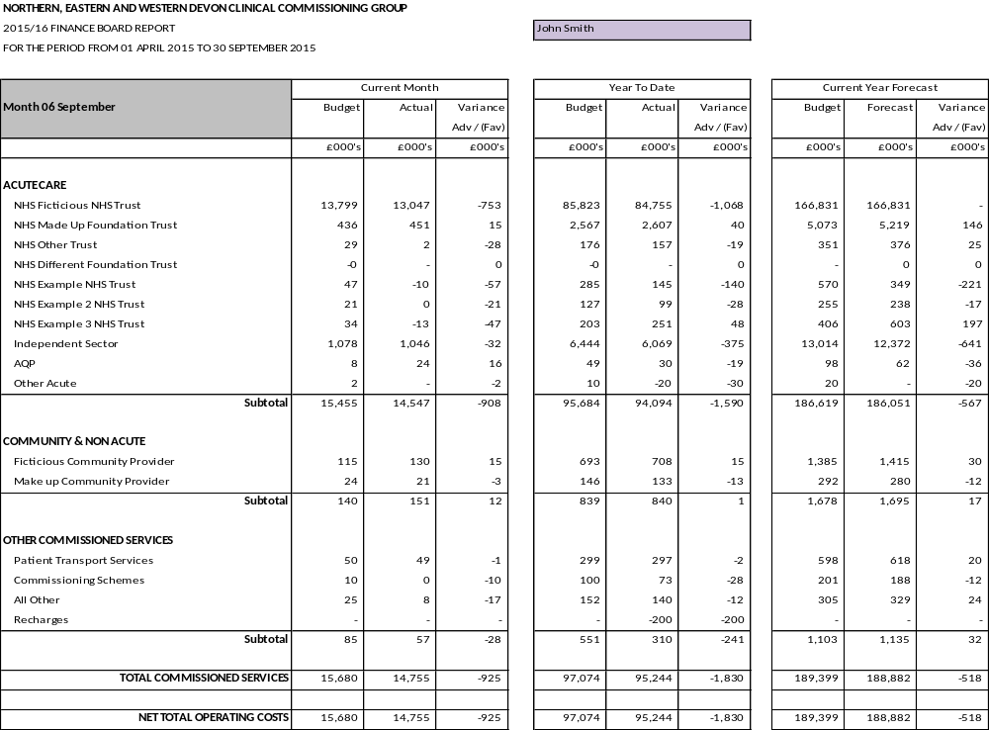
Appendix 3 – Example Running Cost Budget
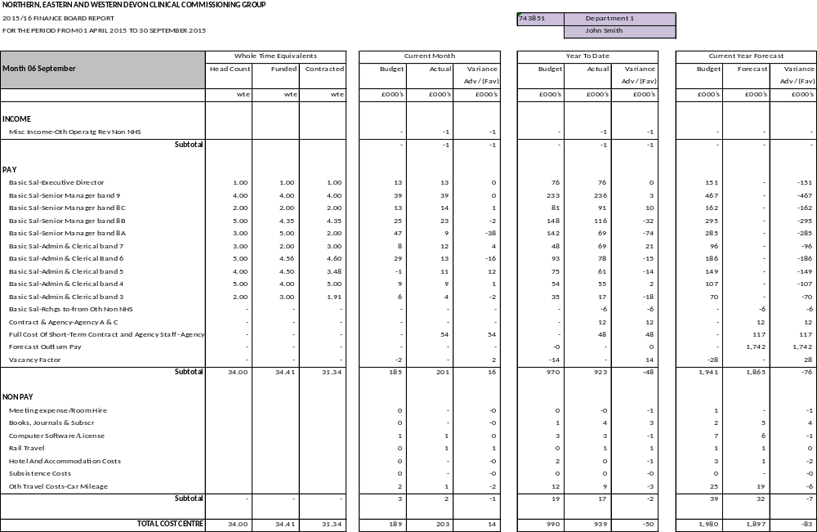
Appendix 4 – Basic Oracle guidance

As a budget holder, you will need to become familiar with the Oracle database that we use to populate our ledger. This section will summarise some basic functions which may aid you when using Oracle.

1.0 Accessing Oracle:
To access oracle you must log in to the Oracle ISFE zone via the Oracle internet page.
http://nww.sharedbusinessservices.nhs.uk/oraapps.html
Select the red Oracle ISFE login button and enter your username and password. This will take you to your Oracle Responsibilities page. The number of options available to you will differ depending on the responsibilities you are required to have. This will be determined in the Oracle User set up process.
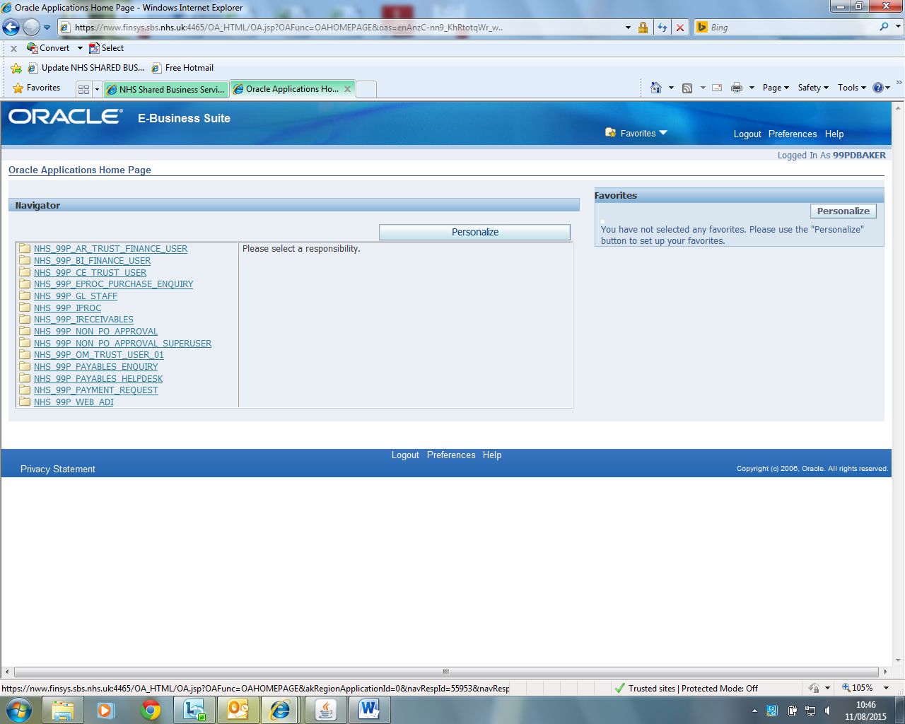
Key Responsibilities:
NHS_99P_NON_PO_APPROVAL – This is your core oracle inbox where invoices will sit awaiting to be approved
NHS_99P_PAYABLES_HELPDESK – This is the main helpdesk function which is used to search/check the history of all previous invoices.
NHS_99P_IRECEIVABLES – This is the Accounts Receivable search function which is used to check on the status of customer accounts.
NHS_99P_IPROC – This function is used to order stock/equipment through the PO procurement side of the ledger.
Your main responsibility as a budget holder will be NHS_99P_NON_PO_APPROVAL which is where you access to code and approve invoices for payment.
To access this responsibility, simply select it from the list by clicking on it.
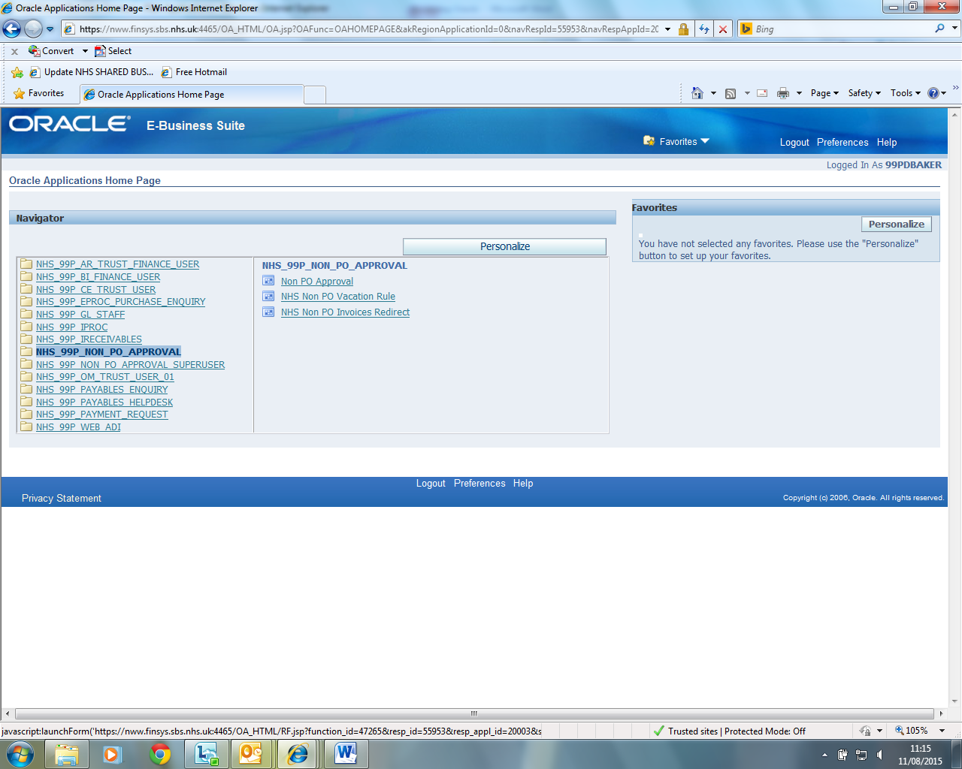
You may then receive a series of dialogue boxes giving you a Run or Cancel option. Click Run on all boxes that appear (normally 2 or 3). The Oracle application should now open up and you should now see your Oracle inbox.
2.0 Understanding Your Oracle Inbox:
You will now be logged in to your Oracle inbox homepage which will look similar to the below example:
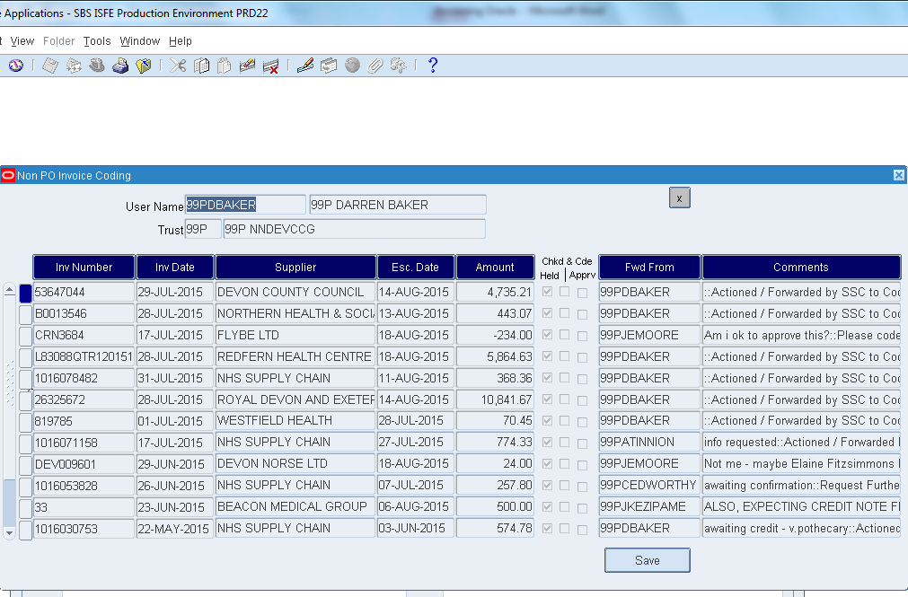
User comments which have been inputted to provide relevant information needed.
Forward From: Shows the person who has forwarded you the invoice.
Escalation Date: The date at which, if no action is taken, the invoice will be escalated to your line manager for action.
Confirms and actions all changes that have been made such as invoice approval
Blue Button: Click to access the individual invoice record to allow coding/approval of invoice.
The main page (as above), provides you with an overview of all the invoices currently awaiting action from you. These will be sorted by default (from top to bottom) in the order that they appeared in your inbox (most recent at the top). You can sort them how you wish by clicking on any of the dark blue headings. From this screen you can access each individual invoice and action as is necessary.

2.1 Invoice Detail Screen:
Select the invoice you wish to deal with by selecting the blue button to the left of the invoice number. This will bring up the detailed information for the selected invoice.
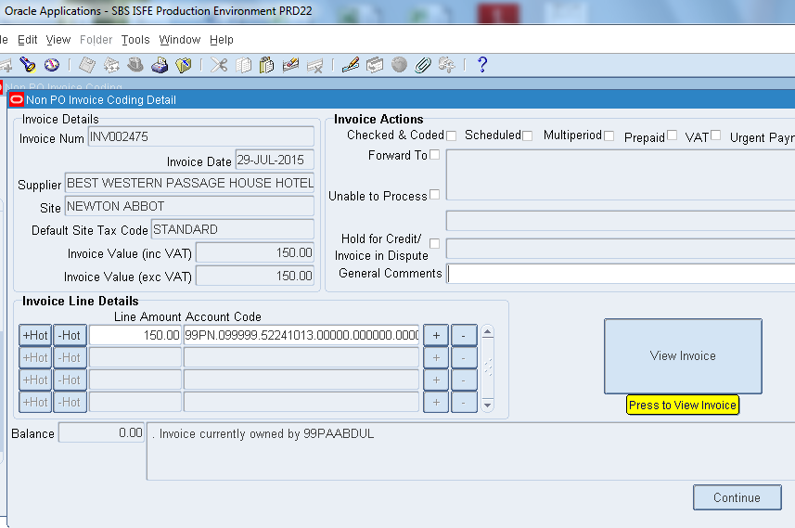
Open up the invoice image and ensure that all the relevant details match the invoice image.
2.2 Viewing the Invoice:
To view the invoice, click on the “view invoice” box which will open up a copy of the invoice image in a web browser. It is then necessary to check that the details on the invoice image match the details showing on the database record page. If you are happy with the invoice details then proceed to coding and approving the invoice (see Section 5.2)
If you are not happy with the invoice, then please contact the supplier directly to either resolve the dispute or request a credit note. Place the invoice on hold and enter any relevant information in the comments box which will allow the progress of the dispute to be followed.
Previous comments can be viewed by accessing the record history in the tool bar.
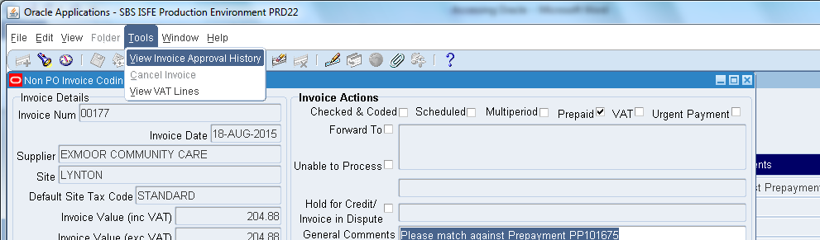
You will then be able to view any previous comments and coding that has been entered on to the record.
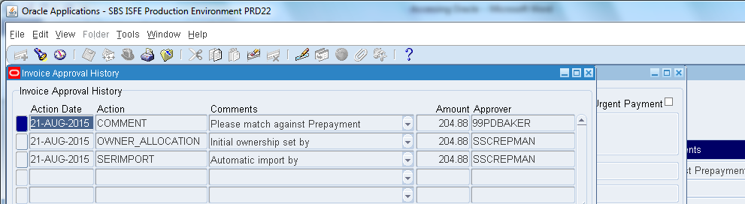
3.0 Login Problems
When you are set up for use in the Oracle ledger, you will receive a username and password to enable you to login to your account. Your Username will normally be in the format of 99P + your first initial followed by your surname (e.g. Dave Thomas would be 99PDTHOMAS).
Should you at any point forget your login details, you can request a reset by visiting the Oracle log in assistance page. This can be done by clicking the link ‘login assistance’ on the main Oracle login page.
You will be given the option of resetting your password by inputting your username, or you can request your username by inputting your email address.
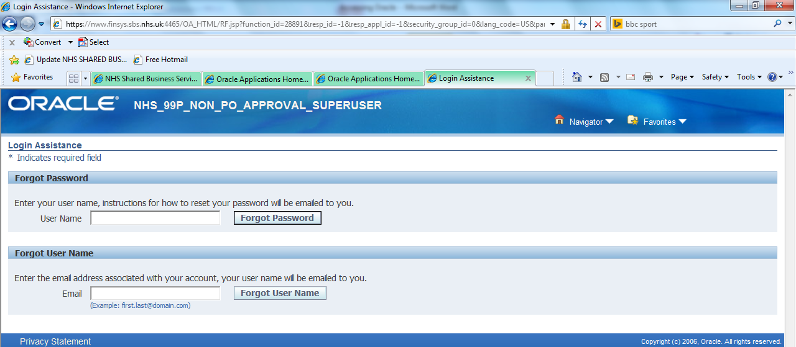
In both cases, your requested details will be emailed directly to your NHS mail account with approximately 15 minutes.
4.0 New Oracle User Set Up Requests
In order for new starters or delegated budget holders to access oracle, they may be required to submit a new user set up request. For new users this will be part of the new employee checklist managed via HR. For new users already employed within the CCG this is managed through Mark Neville-Smith on (mark.neville-smith@nhs.net )
5.0 Invoice Authorisation Process
5.1 Coding an Invoice:
At present we have a central coding system and so the majority of invoices will come to you already coded. However, as a budget holder it is vital that you are aware of your codes so that any mistakes can be corrected. It is the budget holder’s responsibility to ensure that the correct code is in place when the invoice is approved. Each budget holder should hold a list of codes that they maintain responsibility for and so should be familiar with these. The accuracy of the expenditure reported back to budget holders is dependent upon the accuracy of the coding at the outset. It is therefore essential that the coding is accurate and so if unsure of coding, please liaise with your management accountant at the earliest opportunity.
To code an invoice, click into the invoice coding line just to the left of the ‘+’ button.
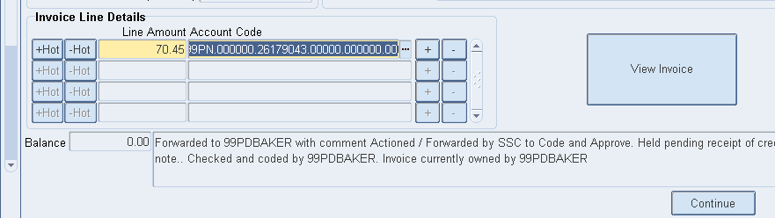
This will bring up the invoice coding menu.
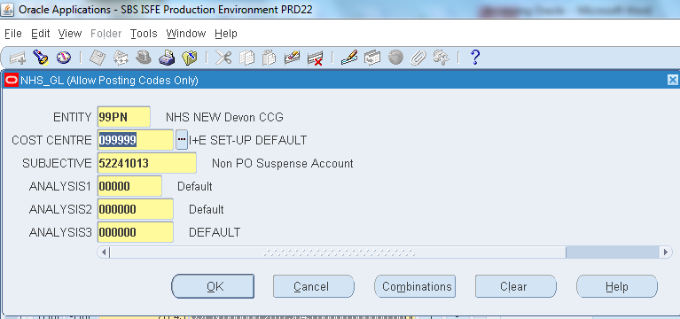
You can then manually type in the correct codes, or use the search function to find the appropriate code.
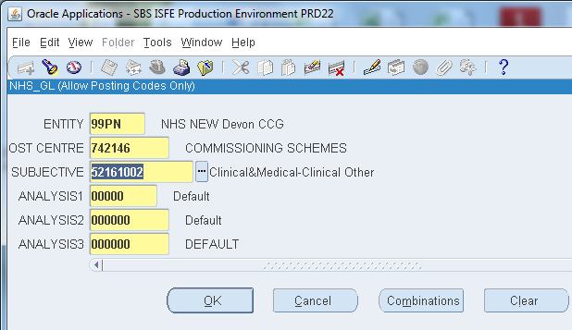
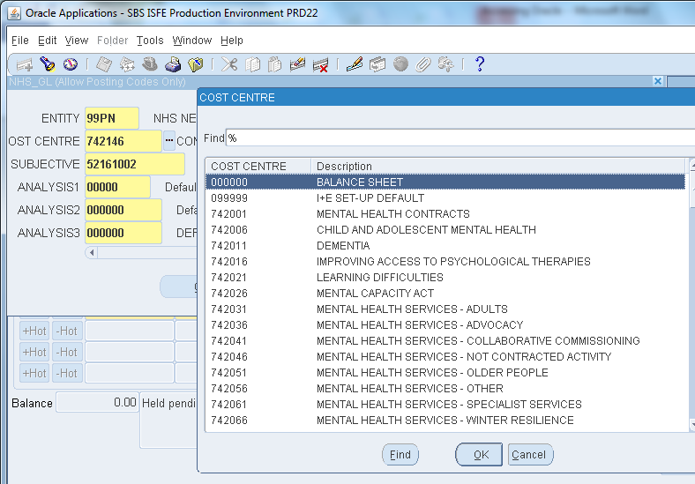
If the code combination is correct, when you press ok to confirm the changes you will be returned to the main invoice detail screen. You can then proceed to approving the invoice or taking any further required action (see ‘Approving an Invoice’).
Manually input the codes by typing in the numbers
Or
Use the search function to find the codes.

If the code combination is not valid or set up, you will not be allowed to leave the coding screen until you have corrected it to a valid code combination. If you are certain that the combination you are using is correct, then you can request the code combination be set up by following the Code combination Set-up process.
5.2 Approving an Invoice:
As a budget holder you maintain complete responsibility for any spend/invoices which you sign off (approve). It is therefore extremely important that you have adequately checked and are completely happy with the invoices before you approve them.
As a budget holder, you will be assigned an Oracle Approval limit in line with the CCG’s Standard Financial Instructions and Scheme of Delegation Policy. You can approve any invoice which is below or equal to your designated limit.
Once you have followed the process in 5.2a, you can now approve the invoice in oracle and submit it for payment. To do this you must click on the approve button at the top right of the coding screen.
Please note that if the invoice value is above your approval limit then the button will be labelled “Checked and Coded” and not “Approve” (as below).

If Invoice value is within your approval limit this will say “Approve”.

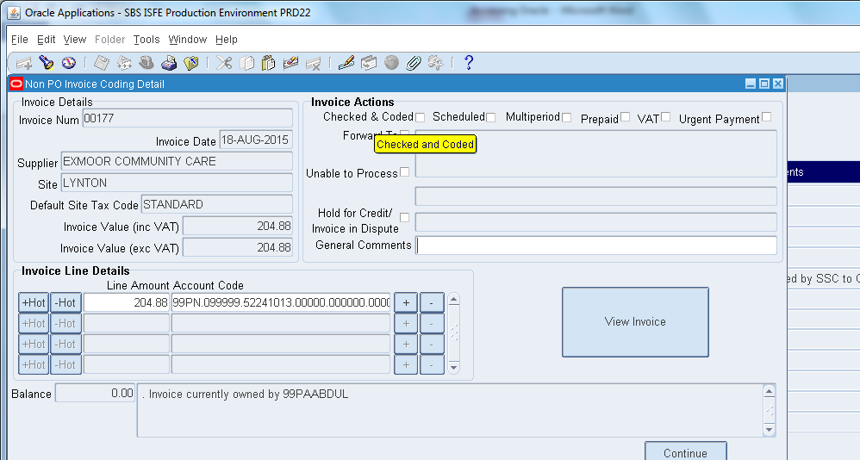
If the Invoice value is more than your approval limit then this will show “checked and coded”
Ensure that the Hold box is unticked before approving
5.3 Within your approval limit:
Once you have ticked approve, you then need to press continue to exit the invoice record and then press save on the next screen. This will remove the invoice from your inbox and send it for payment on the next available payment run. Once you have selected save, you will be unable to make any changes to the invoice again.
5.4 Above your approval limit:
If the invoice is above your approval limit, you will receive the following pop up box after selecting “Checked and Coded”.
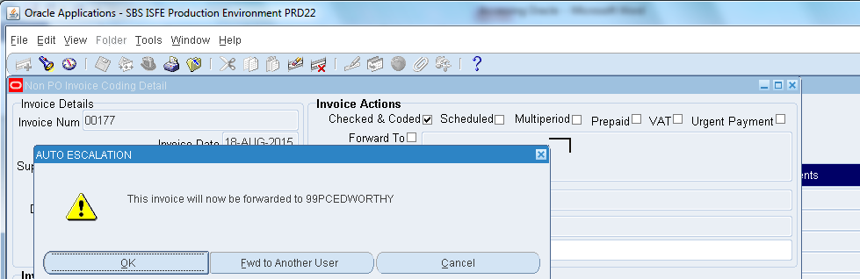
You can either select ok which will send the invoice to your line manager for further approval, or you can redirect it to a specific person for approval by selecting “Fwd to another User”.
The recipient should then be notified of any information relating to the invoice in order to allow them to approve as above.
5.4 Approving a Credit Note
Credit notes are approved in the same way that an invoice is approved, as detailed in the previous section.
Where possible, credit notes should be approved at the same time as the invoice it relates to and should always be coded to the same code as the relating invoice.
5.5 Prepaid Invoices
In some situations it may be necessary for the CCG to make a prepayment on an invoice (e.g. when an invoice is not on the system or payment is very urgent). This is normally done by a Faster Payment which is detailed later in this manual.
When we receive the invoice for this spend, we then have to ensure that the prepayment is matched against the invoice correctly and ensure that the payment is not duplicated.
This will normally be completed by the finance team prior to you receiving the invoice for approval. In these cases the invoice will have a tick marked against the prepaid box along with comments detailing which prepayment the invoice is to be matched against.
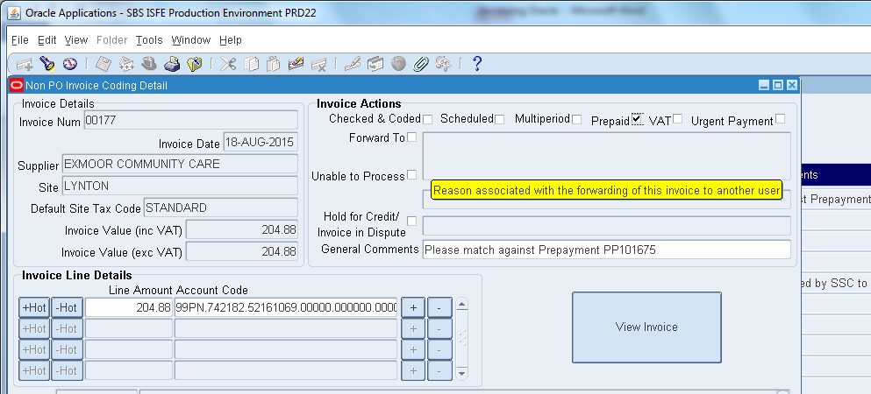

In these cases, Please approve as normal but ensure that the prepaid box is ticked when you select approve. This will ensure that the invoice is placed on a pre-paid hold post approval and then subsequently matched to the appropriate pre-payment.
6.0 Payment Runs
Approved invoices are kept back until the next payment run where they are released for payment. These runs occur on different days depending on the type of organisation that is being paid and also the date the invoice is approved. The table below lists some key dates for the CCG’s payment runs.
6.1 The below table is for Non-NHS Suppliers:
Type of Run | Day of Run | Time Invoices to be approved by in order to be included on run. | Date funds received by Supplier.
BACS | Tuesdays + Fridays | 4pm Previous working day (e.g. 4pm Monday/ 4pm Thursday) | 3 Working days from date of Payment Run.
Cheque | Fridays Only | 4pm Thursday before | 7-10 Days

6.2 NHS Suppliers:
NHS Suppliers are paid by a different method known as an RFT (Rapid Funds Transfer) payment. RFT runs take place on the 1st and the 15th of each month. If the 1st falls on a non-working day, then the run will take place on the first working day of the month; if the 15th falls on a non-working day, then the run will take place on the last working day before that date to ensure the funds are received by that date.
All invoices need to be approved by 4pm the day previous to the RFT run. Once submitted, the funds are then cleared into the suppliers account on the same day to ensure that strict NHS payment terms are met.

Appendix 5 - Budget Holder Databases Guidance

1 How to find the Monthly Budget Holder Reports
The Budget Holder Reports are located in the N drive:

N: Budget Holder Reports

Open this folder to see the folders for each budget holder. You can only access the folders where you have budget responsibility. Double click on your folder a file name will appear with an Access Database symbol named either:

Prog_Bud_Nnnnnn_N OR
RCosts_Nnnnnn_N_Yyyyyy

In both instances Nnnnnn_N is the name of the Budget holder
For Running Costs reports Yyyyyy is the name of the budget area.

2. Navigating the screens

2.1 – Programme Budget Holders.
Double click the Access file name to see the first screen
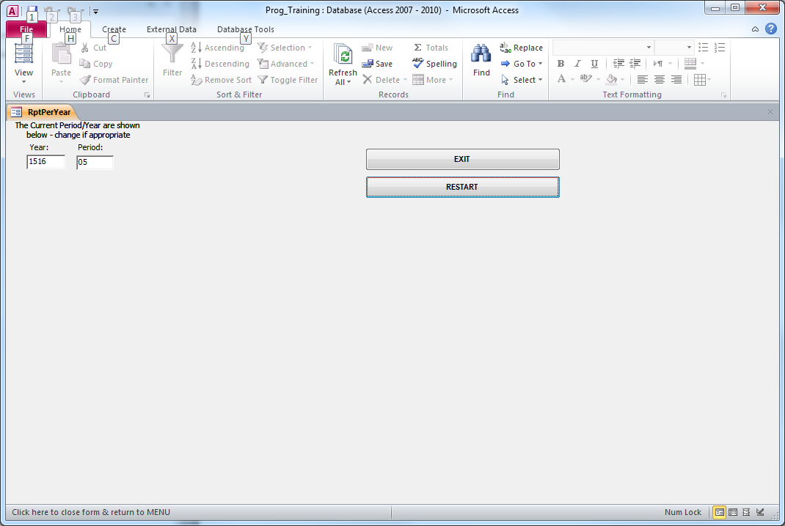

Move the cursor to the RESTART button and single click (left mouse button) to move to the first level of information. The first level of information is at Board Summary, showing the Board ID and description.

For each Board ID the current month values for Budget (CMBUD), Actual (CMACT), and Variance (CMVAR) are shown in the first block.
The second block provides values for the Year to Date for each of Budget, Actual and Variance (YTDBUD, YTDACT, YTDVAR).

The third block shows the current year budget (CYBUD), the forecast outturn for the year (CYFOT) and the variance between the two values (CYVAR).

The last block – a single column is next years’ budget (NYBUD).

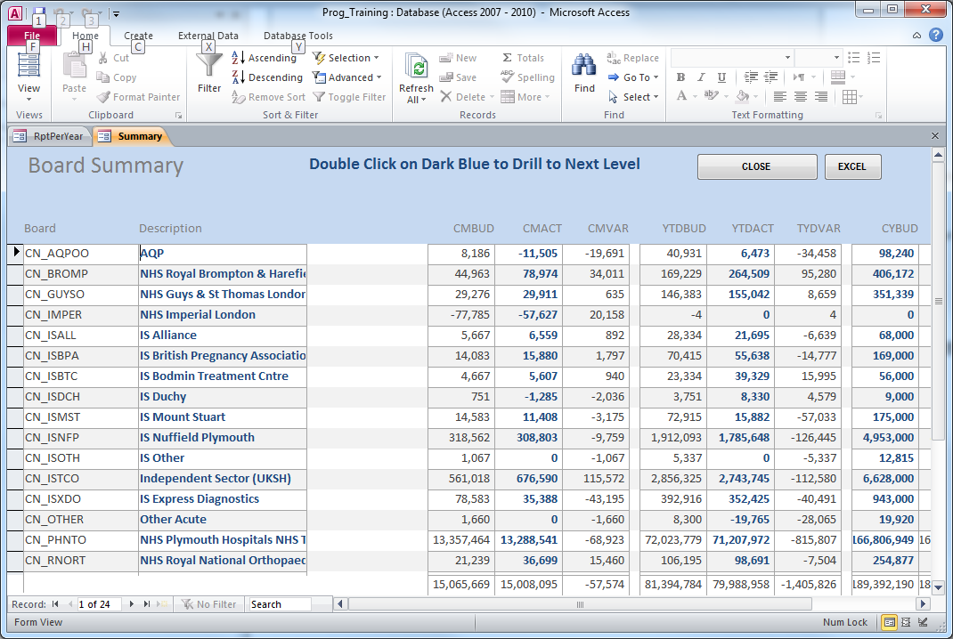

Drilling down through reporting levels
The data provided can be used at several levels. The level shown above is the Summary Level where all Board IDs are shown for which you are responsible.

To access lower levels of information you need to double click on the dark blue text/numbers to drill down. The blue text is also in bold to help distinguish it from information that cannot be drilled. You can drill down on the description for a Board ID and will see changes in the information presented.

The next level down is the summary for the individual Board ID (Summary)
The next level down is for Cost Centre Totals (CC Totals)
The next level down (Analysis) shows the code combinations that are linked into the Cost Centre.

At this stage further information is found that relates to the expenditure (or income) in current month or year to date. There is also the ability to drill down into the current or next year budget.

[To go back a level use the ‘Close’ button; each time you use the button you move up a level.]

Drilling down the values
Double click (left mouse) any blue value to see the underlying detail. The screen being viewed is then at Transactions level.

At this level you have the ability to see the invoice relating to a transaction by double clicking ‘View Invoice’ which bring up a pdf view of the invoice in a separate window.
2.2 – Running Costs Budget Holders

The screen that you will see once you hit the ‘Restart’ button will contain additional information for staff, showing FWTE,AWTE,CWTE and WWTE columns from Summary Level down through the levels. There is no drill down facility for the staff numbers.

The next level down is Cost Centre level, and the screen will show three lines – Income, Non Pay and Pay.
The next level down is Subjective and shows the information for each subjective (account description).
The next level down from AC_DESC is Analysis, drilling down a level on blue values takes you to the lowest level:
Transactions, and at this level you have the ability to ‘View Invoice’ for Non Pay.
Currently there is no View facility for Accounts Receivable invoices.

3. Exiting the Budget Holder Report
Hit the ‘Close’ button to move up a level, and move up the levels until you arrive at a screen with a button marked ‘Exit’. Hit that button and the report closes.

4. Excel Download
If you want to copy the data to Excel so that you can manipulate the data click the Excel button, and that data is exported into an Excel file.
Although this file will have a name (the date and time you created the file, rename it with a filename you want to work with
.
IF YOU DO NOT RENAME THE FILE THERE IS A POSSIBILITY THAT THE NEXT EXCEL FILE YOU SEEK TO DOWNLOAD WILL FAIL (ALTHOUGH YOU SHOULD BE OK IF IT IS MORE THAN 60 SECONDS SINCE THE PREVIOUS DOWNLOAD YOU SHOULD HAVE NO PROBLEM)

5. Understanding the Information
The use of the drill down facility for the current month, year to date and for budget values, and the usefulness of Excel will be taught in the Budget Holder workshops. Please contact your management accountant if you were unable to attend and would like some guidance on the use of the database.

6. Queries and Support
Please contact either Ivan Court (ivan.court@nhs.net) or Jo Moore (jo.moore1@nhs.net).

14th Sept 2015

